My first graph will be a evolutiary tree of 1000+ mammal species and I’ll look how with speciation the brain size is evolving amoung them. The graph will look like something following with my data points. I will only use the data of species which were not hibernation. As hibernation play a role in shirinking brain size.

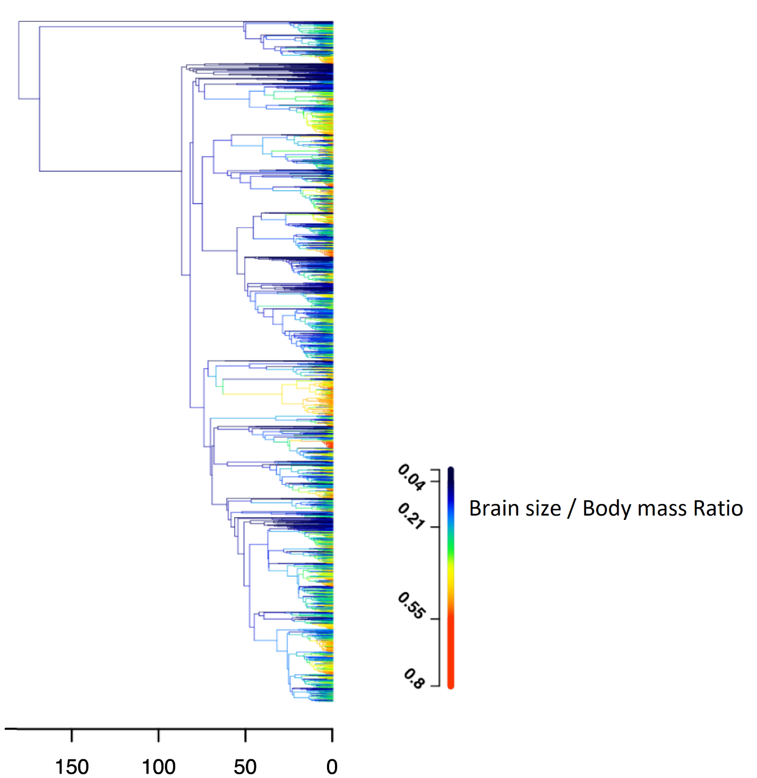

My second graph will be log of body mass on x-axis and brain mass on y-axis. The points will be drawn for each group of mammals in different colors and a intercept line will be made for each group. R2 values will be calculated to see which group has the most brain mass to body mass relation. And how that relation is changing with evolution.

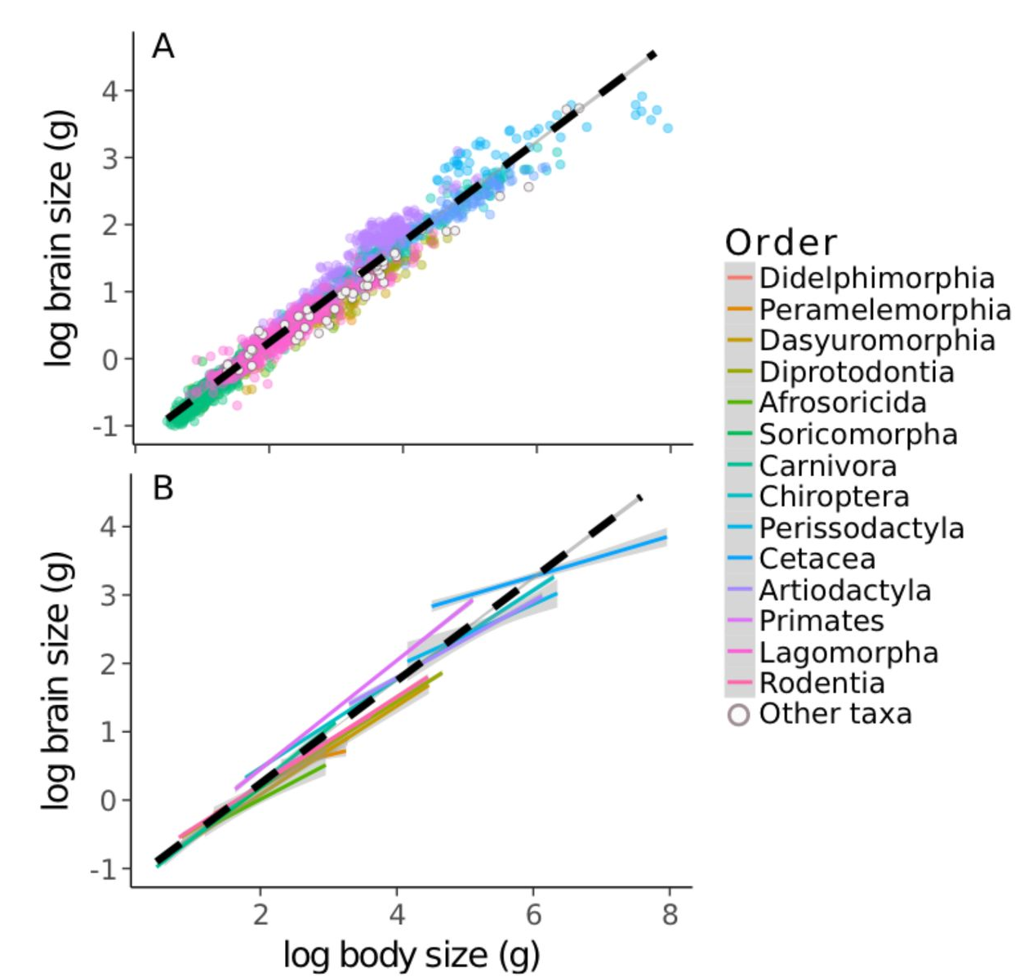

**Papers I have found so far for this project.**

Barton, R. A., and I. Capellini. 2011. Maternal investment, life histories, and the costs of brain growth in mammals. Proceedings of the National Academy of Sciences 108:6169–6174.

Heldstab, S. A., K. Isler, and C. P. van Schaik. 2018. Hibernation constrains brain size evolution in mammals. J. Evol. Biol. 31:1582–1588. **(Data Points from this paper)**.

Schoenemann, P. T. 2004. Brain Size Scaling and Body Composition in Mammals. Brain Behav Evol 63:47–60.

Sol, D., S. Bacher, S. M. Reader, and L. Lefebvre. 2008. Brain Size Predicts the Success of Mammal Species Introduced into Novel Environments. The American Naturalist 172:S63–S71. The University of Chicago Press.

000.

<https://storage.googleapis.com/plos-corpus-prod/10.1371/journal.pbio.2002792/2/pbio.2002792.pdf?X-Goog-Algorithm=GOOG4-RSA-SHA256&X-Goog-Credential=wombat-sa%40plos-prod.iam.gserviceaccount.com%2F20210329%2Fauto%2Fstorage%2Fgoog4_request&X-Goog-Date=20210329T115908Z&X-Goog-Expires=3600&X-Goog-SignedHeaders=host&X-Goog-Signature=>

<https://sci-hub.st/10.1111/evo.13811>

<https://sci-hub.st/10.1086/589461>

<https://sci-hub.st/10.1086/589460>